An android application is built to capture the sensor data . In this application we captured data of accelerometer,gyroscope,humidity and pressure.



This is the sensor file I created.

First Juno is downloaded in local machine. Then we will install glassfish server.

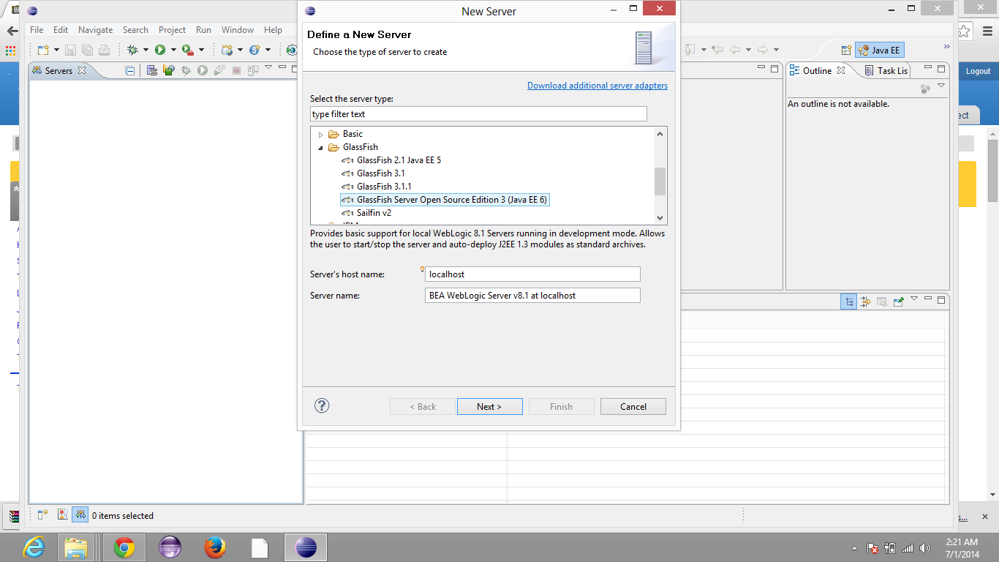

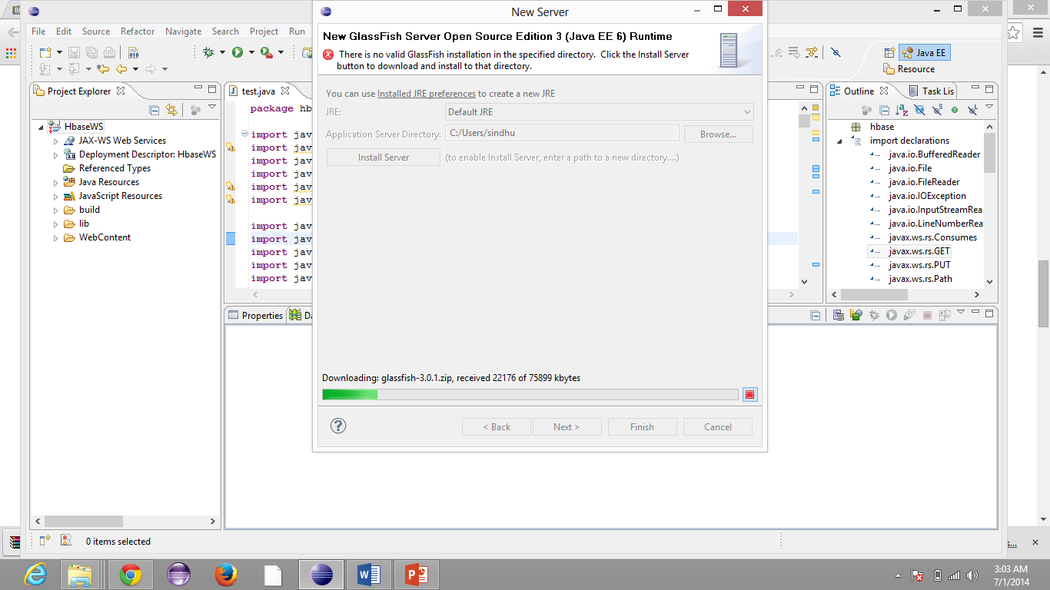

After that we need not give any name and we should click next.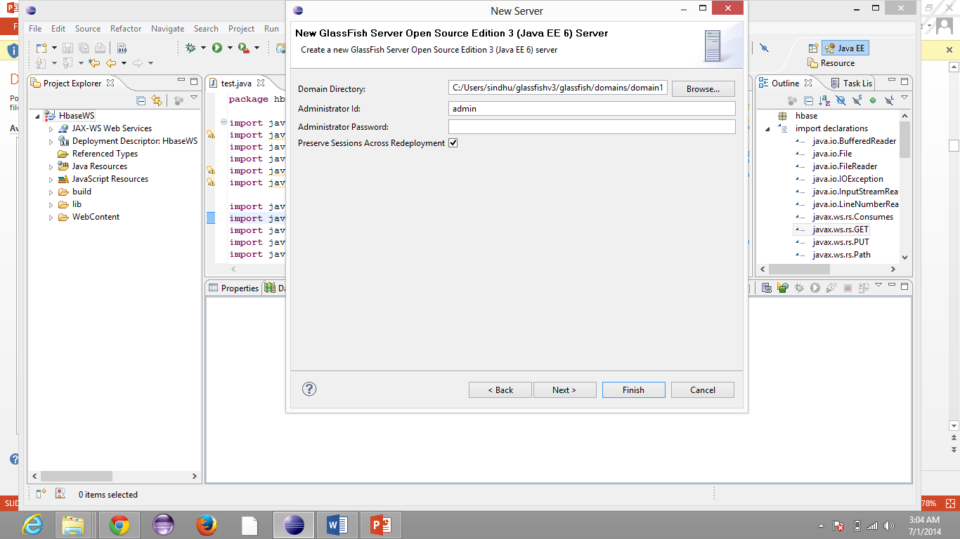

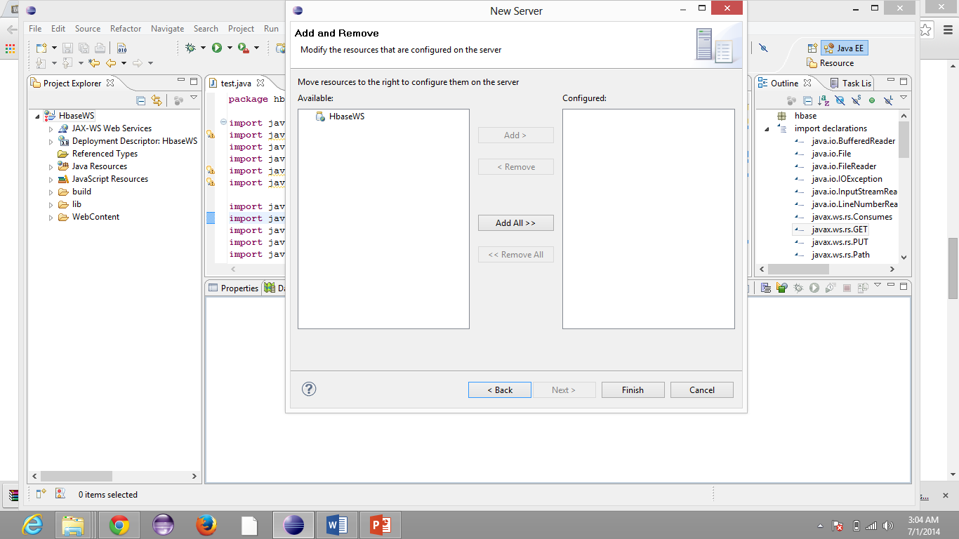

Now we need to start the server

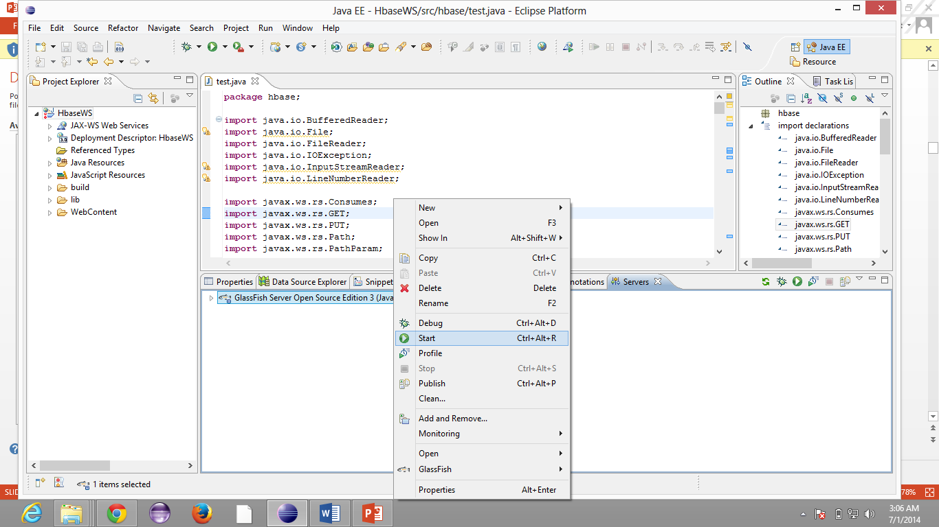

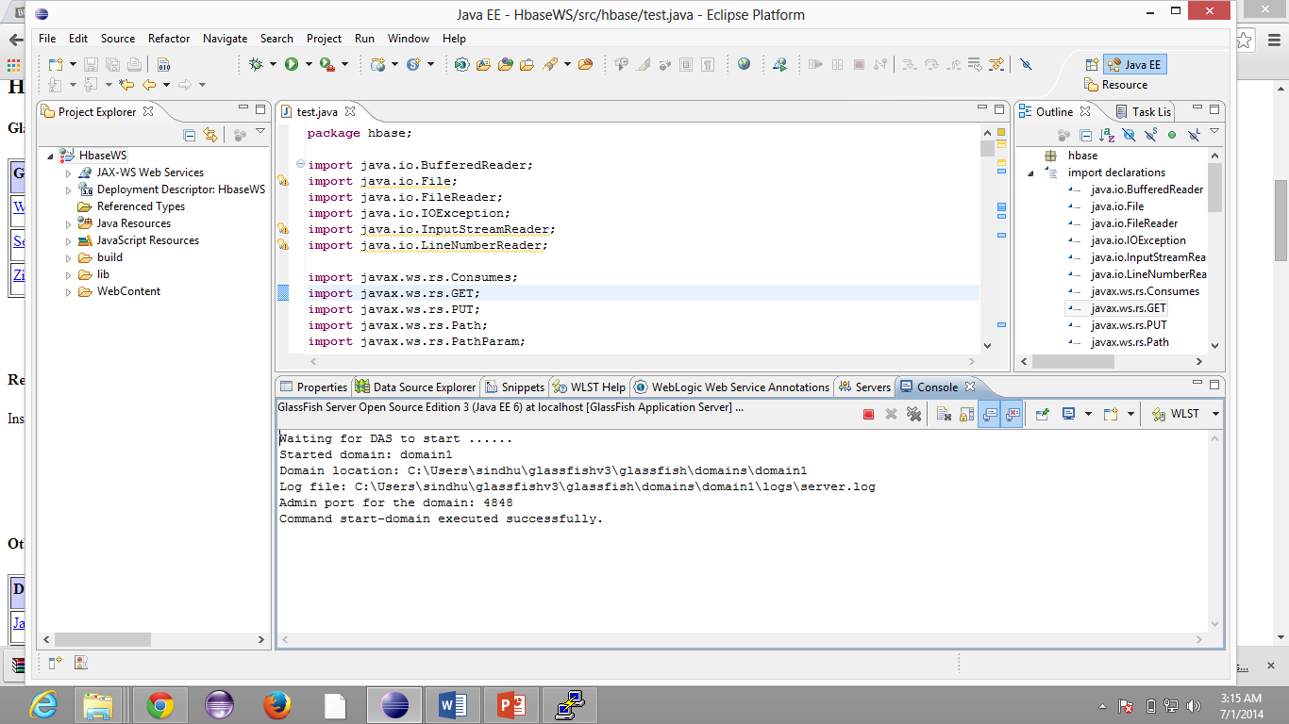

Lets run the project on server.

On our local computer , we open glassfish remotely

http://134.193.136.147:4848

and login with username admin password admin

We create a dynamic web project and run it. We get it as follows.

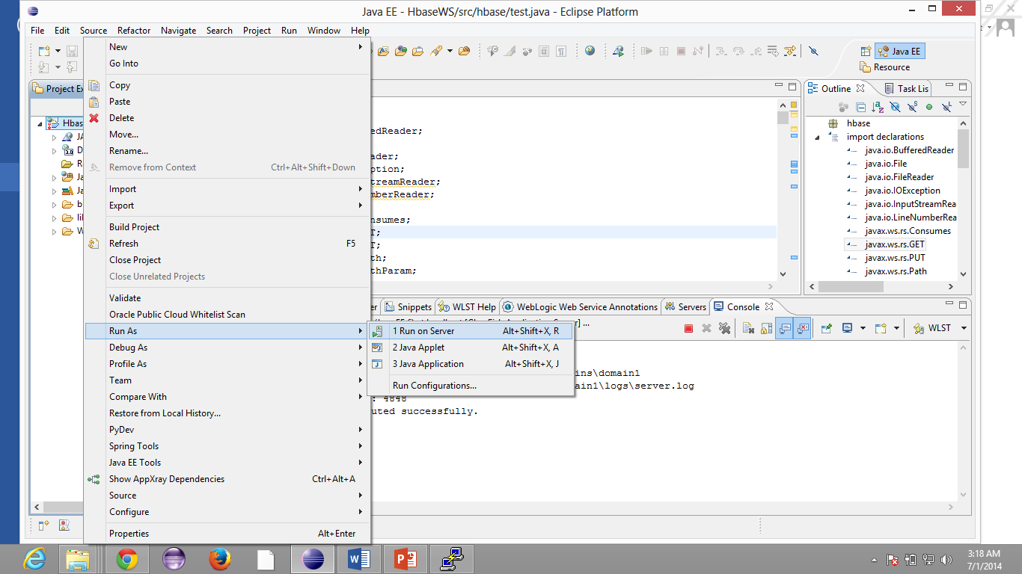

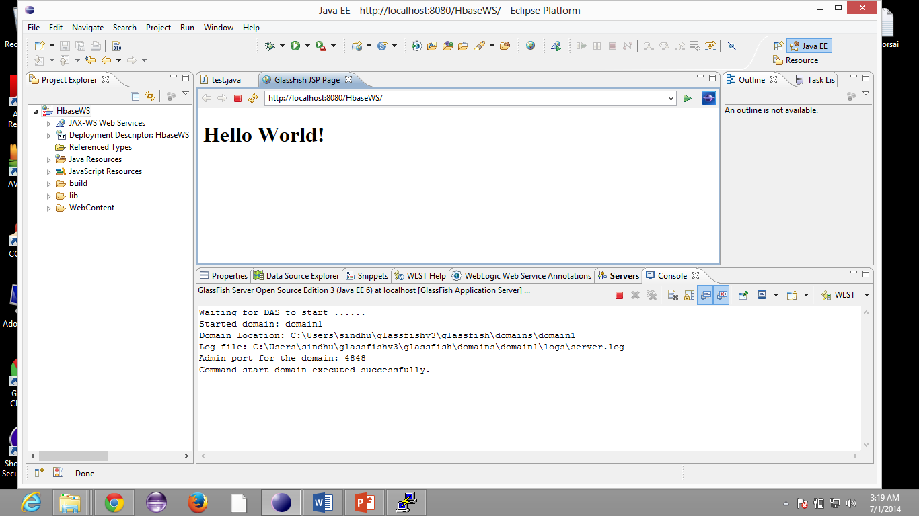

We export war file and save it on our disk. After setting the configurations we open glassfish admin and deploy the war file.

We run the services by invoking the URL.

Sindhu – Table creation

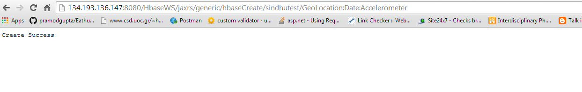

Invoking the URL of delete table

Sindhu – Table deletion

